**Sample Exam 2**

Paddy Watt’s is a bookmaker’s chain with outlets in most towns in Ireland. At the head office in Galway, a database is required to keep track of bets placed in its various outlets.

For this purpose, copies of all dockets are sent electronically to the head office. Details are then inserted into the database.

Task 1

1.1 Create a database named ***Paddy Watts Betting***

* Create a Table named ***Betting Details***to store the data displayed below:

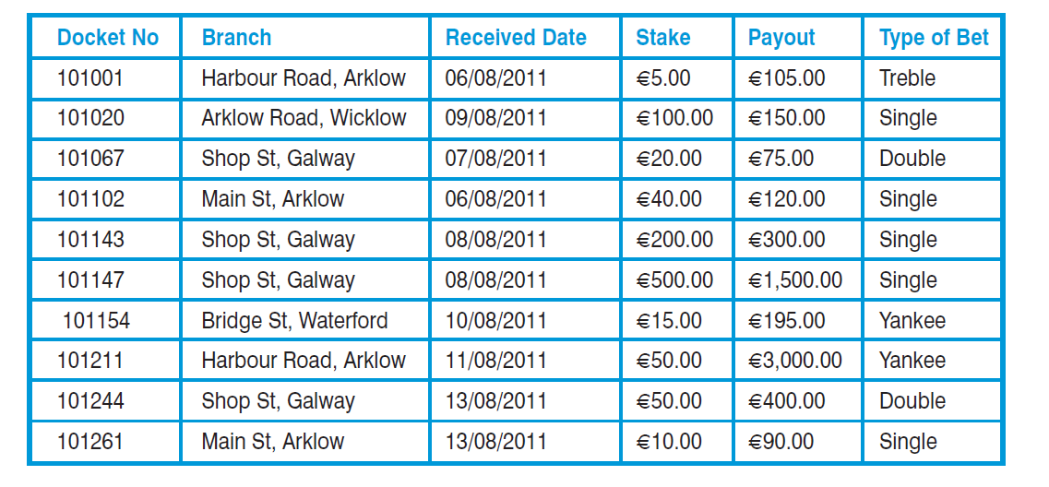

* Set up the ***Docket No***field as the primary key.
* Set up the ***Received date*** field as Short Date
* Set up an index on the ***Type of Bet*** field

1.2 Complete the database structure form provided to show field names, data types and field sizes (see page 5).

Task 2

2.1 Design and create a Form to allow the operator to enter the data shown in the ***Betting Details***Table. The format of the Form should be as follows:

* Insert the title ***Posting Details***centrally on the Form.
* Display two fields on each line.
* Place a label or title beside each field.
* Adjust the width of text box controls to accommodate the data.
* Set the alignment of the ***Branch***text box control to left. Set the alignment of all other text box controls to centre.
* Create a combo box for the ***Type of Bet***field. Each bet type should appear once in the combo box in alphabetical order.
* Line up the label and text box controls both horizontally and vertically.
* Set up the tab order of the form using the order displayed below.

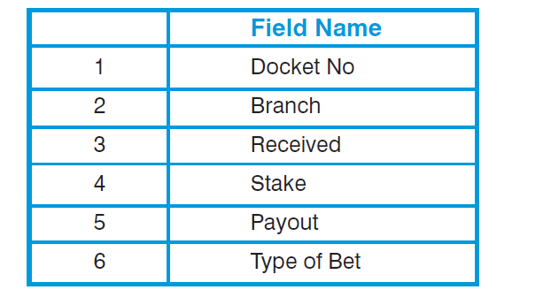

* Save the Form as ***Posting Details***
* Print the ***Posting Details***Form

2.2 Input the data shown in the table using the ***Posting Details***Form.

Task 3

Create Queries for each set of criteria listed below.

*Note: Print each Query as you complete it.*

3.1 Select and print all records for bets at the Harbour Road, Arklow branch.

* Sort the Query in descending order of ***Payout***
* Save the Query as ***Harbour Road Arklow***

3.2 Select and print all records for bets placed in either of the Arklow branches (use a wildcard).

* Sort the Query in descending order of ***Payout***
* Save the Query as ***Arklow bets***

3.3 Select and print all records for bets at the Shop St, Galway branch where the Stake was greater than €50.00.

* Sort the Query in descending order of ***Stake***
* Save the Query as ***Galway bets above* €*50***

3.4 Select and print all records for bets at the Galway or Wicklow branches, where the ***Payout*** was between €100.00 and €1,000.00 inclusive and where the ***Type of Bet*** was Single.

* Sort the Query in descending order of ***Payout***
* Save the Query as ***Single bets in Galway and Wicklow***

Task 4

4.1 Add a new field to the ***Betting Details***Table as follows:

* Field Name – Win.
* Data Type – Yes/No.

Add the details of the ***Win***field to the database structure form (page 5).

4.2 Add the ***Win***field to the ***Posting Details***Form and enter the data shown below:

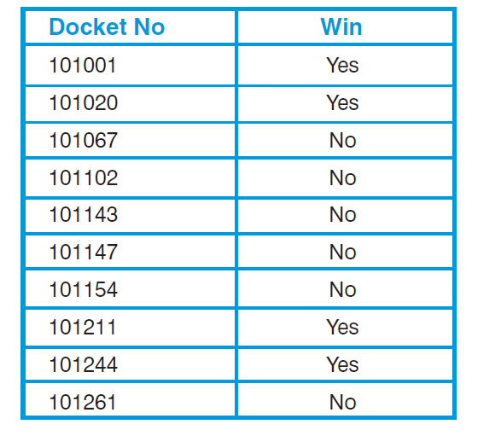

4.3. Input the records displayed in below using the ***Posting Details***Form.

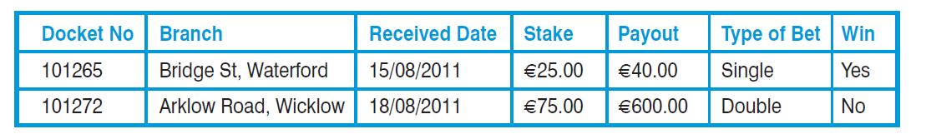

Task 5

5.1 Generate a Report from the ***Betting Details***Table to include the following:

* Show all fields except ***Type of Bet.***
* Sort in ascending order on the ***Branch***field (primary sort).
* Sort in descending order on the ***Stake***field (secondary sort).
* Display the title ***Summary of August Bets***centrally over the data.
* Columns are to be aligned under column headings and evenly spaced across the page.
* Display a grand total for the ***Payout***field, in currency format with no decimals, at the end of the Report. Display the text ***Total Payout***beside the grand total.
* Save this report as ***Summary of August Bets*.**
* Print the Report (in *portrait* orientation)

5.2 Generate a Report from the ***Betting Details***Table, to include the following:

* Show all fields except ***Docket No***and ***Received Date.***
* Sort in ascending order on the ***Branch***field (primary sort).
* Sort in descending order on the ***Payout***field (secondary sort).
* Display the title, ***Betting Details by Branch***, centrally over the Report.
* Display the appropriate field heading centrally over each column of data.
* Use a function to display the average for the ***Payout***field at the bottom of the Report.
* Insert a label with the text ***Average Payout***beside the function. Format average payout to Currency, 2 decimal places.
* Save this Report as ***Betting Details by Branch***. Print the Report (in *portrait* orientation)

Task 6

Produce a set of mailing labels for all dockets *except* those from the Waterford branch.

The mailing labels should have the following format:

* Layout as shown below.
* Have more than one label across the sheet.
* ***Branch***field in bold print.
* Print in ascending order by ***Branch****.*

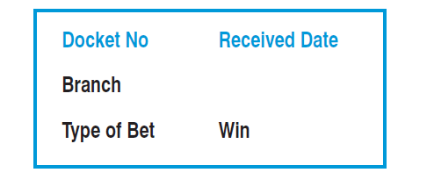

* Save these labels as ***Betting Labels***

Task 7

Generate a report from the ***Betting Details***Table, to include the following:

* Show all fields.
* Group the report by the ***Type of Bet***field.
* Sort the records for each ***Type of Bet***in descending order of *Payout.*
* Display the title, ***Analysis of Betting Results***, centrally over the report.
* Display the appropriate field heading centrally over each column of data.
* Use a function to display the average payout for each type of bet. Insert a label with the text *Average* ***Payout***beside the function. Display the average payout in currency format with 2 decimal places.
* Use a function to display the total payout for each type of bet. Insert a label with the text ***Total Payout***beside the function. Display the total payout in Currency format with no decimals.
* Use a function to display the total payout for all bets displayed in the Report. Insert a label with the text ***Overall Payout***beside the function. Display the total payout in Currency format with no decimals.
* Save this report as ***Analysis of Betting Results***. Print the report (in *landscape* orientation)

**DATABASE STRUCTURE FORM**

|  |  |  |
| --- | --- | --- |
| ***Field Name*** | ***Data Type*** | ***Field Properties*** |
| **Docket No** | Number | Long integer |
| **Branch** | Short text | 100 |
| **Received Data** | Date/time | Short date |
| **Stake** | currnecy | euro |
| **Payout** | currency | euro |
| **Type of Bet** | Short text | 60 |
| **Win** | Yes/no | Yes/no |